**Distribution? What is it?**

* The distribution refers to how the data is spread out or clustered around certain values or ranges.
* By examining the distribution, we can gain insights into the characteristics and patterns of the data, which can be useful in making informed decisions and predictions

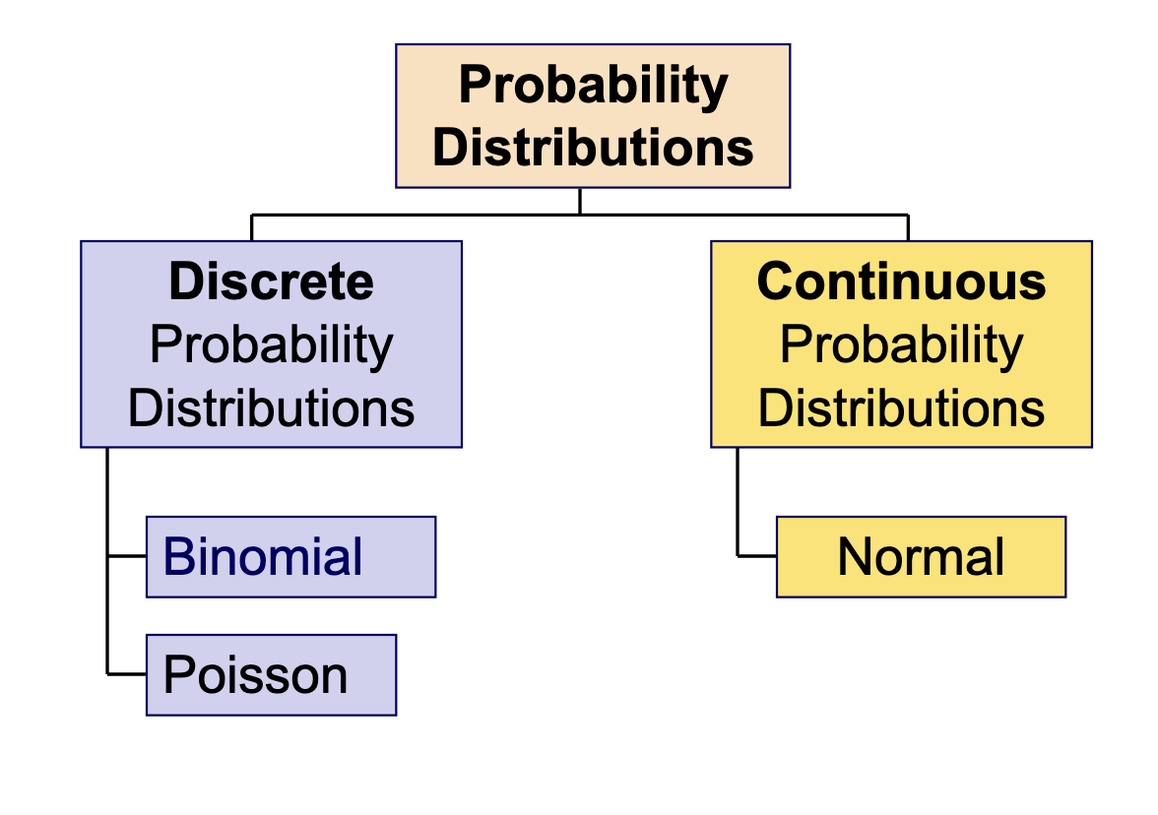

**Discrete Distributions**

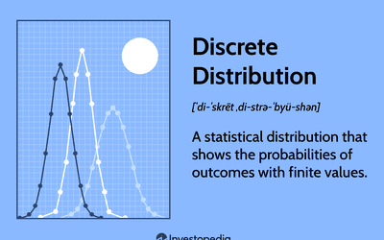

**Bernoulli Distribution:**

* The [discrete probability distribution](https://en.wikipedia.org/wiki/Discrete_probability_distribution) of a [random variable](https://en.wikipedia.org/wiki/Random_variable) which takes the value 1 with probability �p and the value 0 with probability �=1−�1-p.
* Less formally, it can be thought of as a model for the set of possible outcomes of any single [experiment](https://en.wikipedia.org/wiki/Experiment) that asks a [yes–no question](https://en.wikipedia.org/wiki/Yes%E2%80%93no_question).

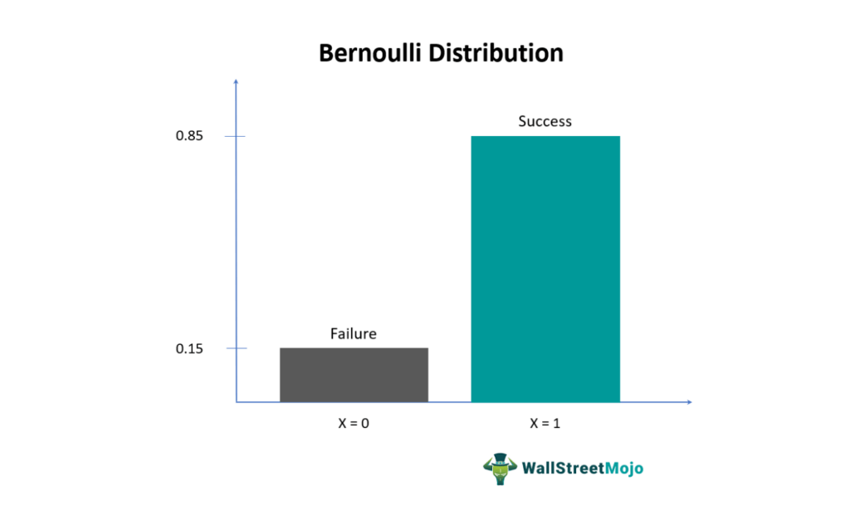

Bernoulli is a special Case of Binomial Distribution!

**Binomial Distribution:**

The binomial distribution is the discrete probability distribution that gives only two possible results in an experiment, either Success or Failure over a **series** of experiments.

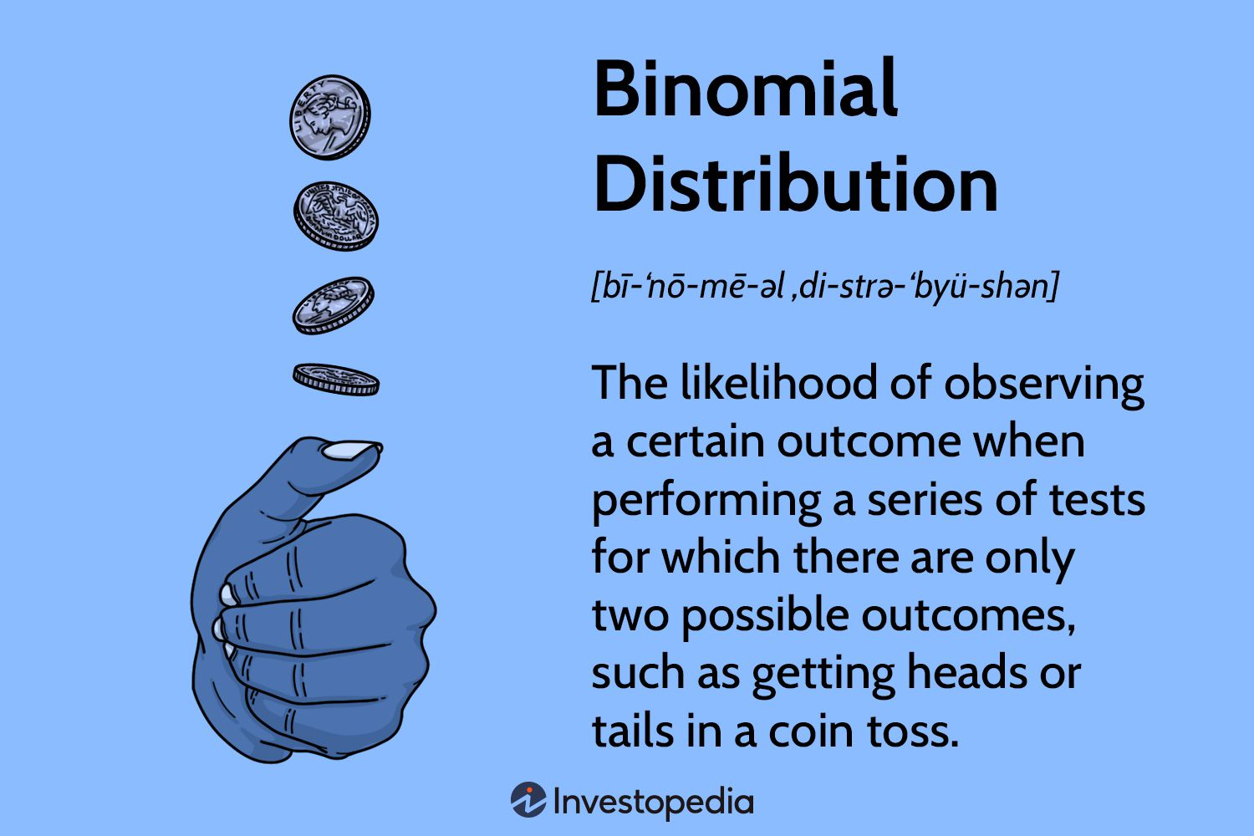



**Poisson Distribution:**

1. A discrete frequency distribution which gives the probability of a number of independent events occurring in a fixed time.

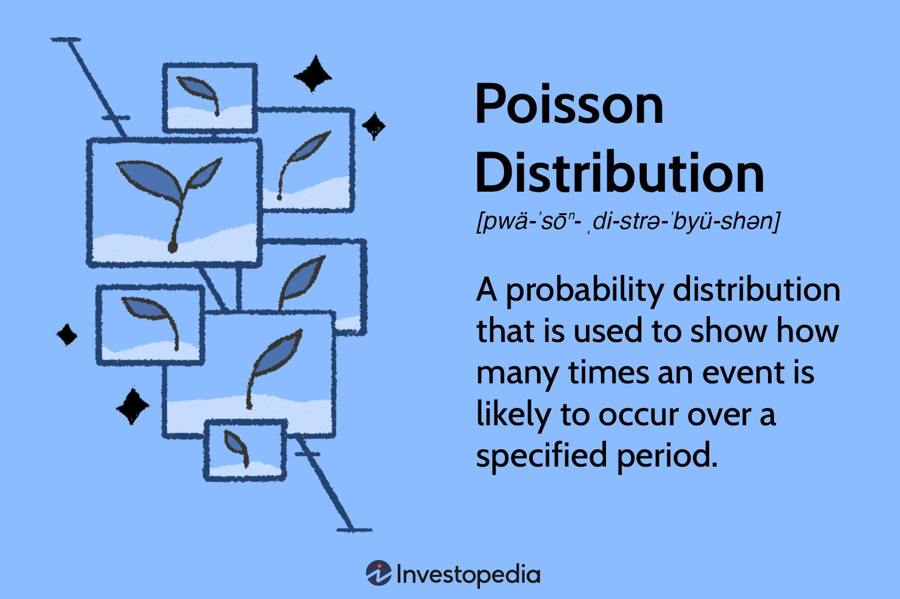



**Continuous Distributions:**

* **A probability distribution in which the random variable X can take on any value (is continuous).**
* **Because there are infinite values that X could assume, the probability of X taking on any one specific value is zero.**

**Normal Distribution:**

1. Data are symmetrically distributed with no skew. Most values cluster around a central region, with values tapering off as they go further away from the center.
2. **The measures of central tendency (mean, mode, and median) are exactly the same in a normal**
3. **It is also called a Gaussian Distribution**

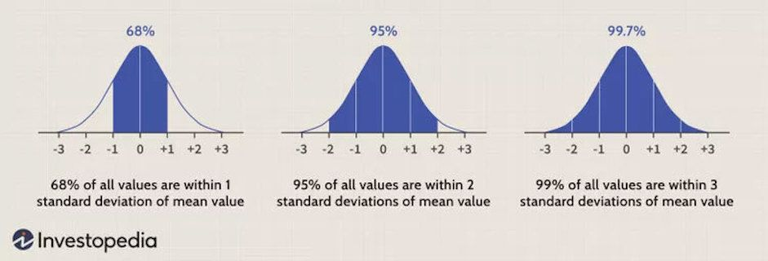

**Look at:** [**https://www.youtube.com/watch?v=CfZa1daLjwo&list=PLaFfQroTgZnzbfK-Rie19FdV6diehETQy**](https://www.youtube.com/watch?v=CfZa1daLjwo&list=PLaFfQroTgZnzbfK-Rie19FdV6diehETQy)